. Generate a data set “Painters” from in-build MASS library and show the data frame and summary of this dataset.
Ans:
library(MASS)
data("painters")
print(painters)
summary(painters)
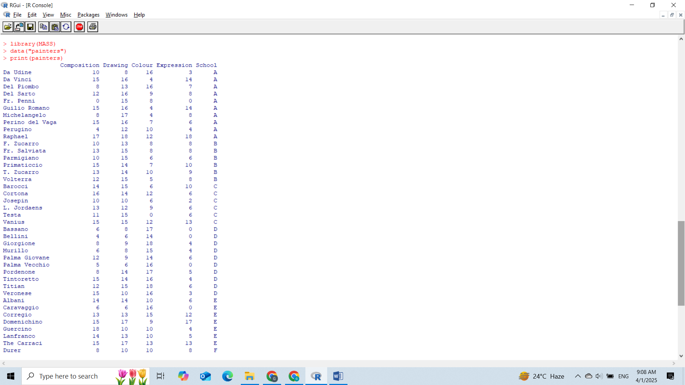

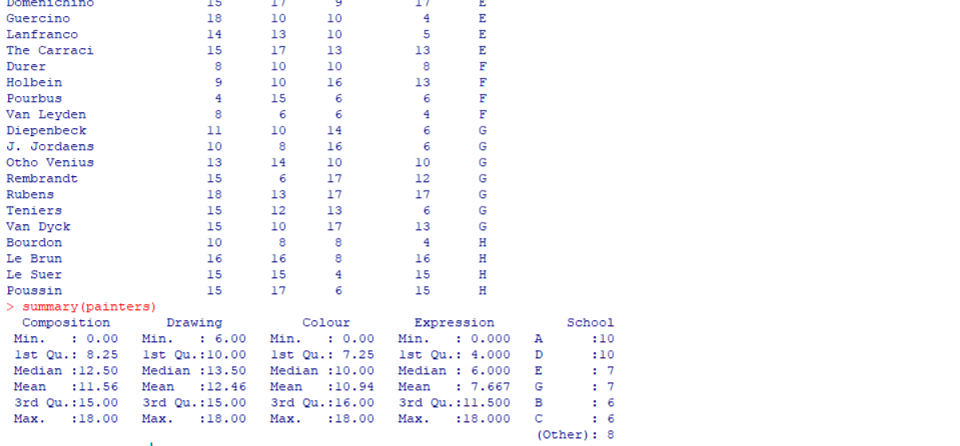
. Write steps to install and load a package “lme4” and show that it is listed in-build packages list.
Ans:
install.packages("lme4")
library(lme4)
installed.packages()["lme4", ]
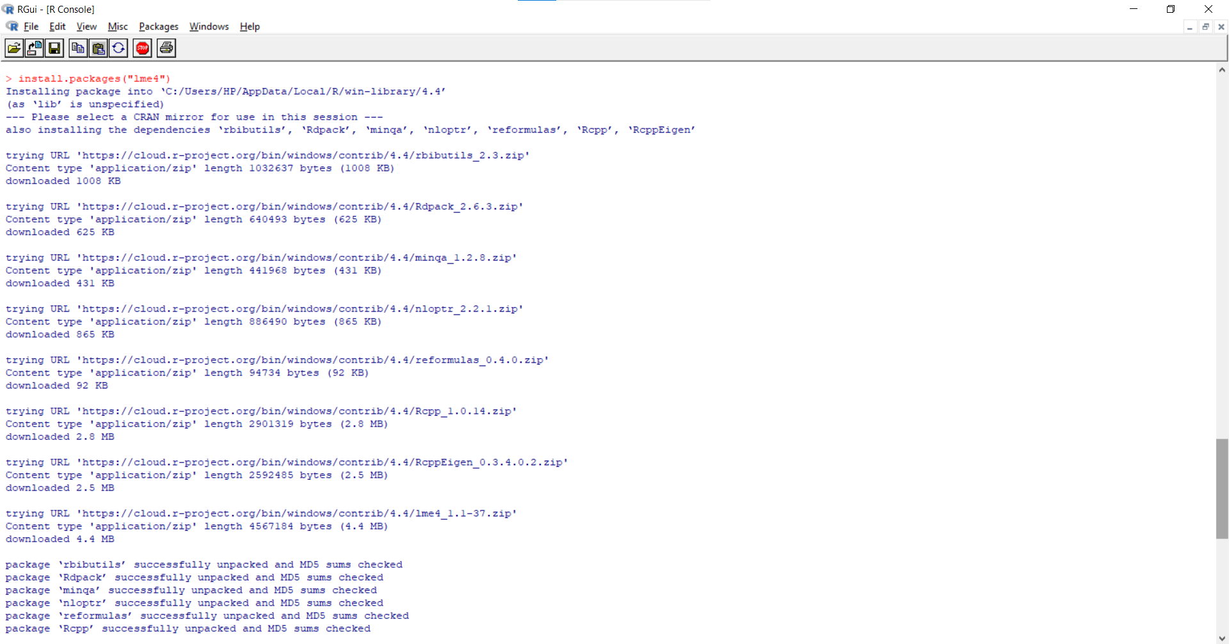
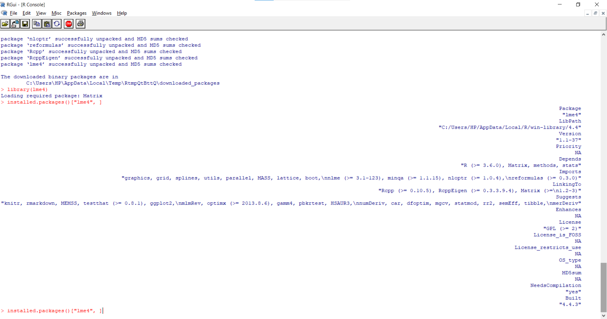
. The following data represent travel expenses (other than transportation) for 7 trips made during November by a salesman for a small firm:
Trip | Days | Expenses_Rs | Per_Day_Expenses
1 | 0.5 | 1350 | 2700
2 | 2.0 | 1200 | 600
3 | 3.5 | 1750 | 500
4 | 1.0 | 900 | 900
5 | 9.0 | 2700 | 300
6 | 0.5 | 900 | 1800
7 | 8.5 | 1700 | 200

Make a data frame with your name on excel and call it on R software platform. Show the data frame via R code and Extract column “Expenses_Rs” with the name data1 and “Per_Day_Expenses” with the name data2. Also, show the summary of data1 and data2 individually.
Ans:
library(readxl)
expenses_df <- read_excel("expenses.xlsx")
print(expenses_df)
data1 <- expenses_df$Expenses_Rs
data2 <- expenses_df$Per_Day_Expenses
summary(data1)
summary(data2)
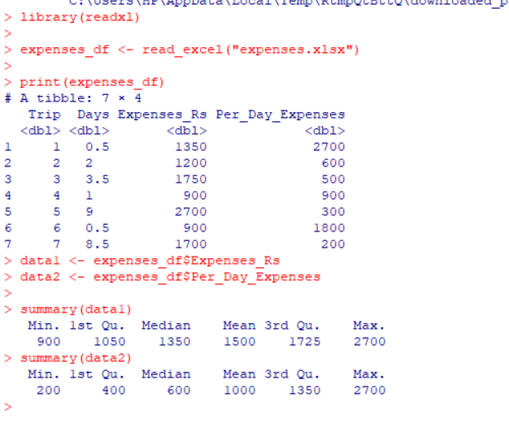
. Define a vector of decimal data whose elements are 9.856302, 3.735875, 1.535875, 5.053216, 6.978234 and perform the following task.
- Task-1: Check the length of this vector and also convert its element to three decimal place.
- Task-2: Abstract the 3rd and 5th element. o Task-3: Abstract all those entries whose values are greater than or equal to 1.
- Task-5: Calculate the square root and natural log of each entry and convert this vector in character and integer vector and check the convert performance by using testing function available in R.
- Task-6: Name the vector element as x1, x2, x3, x4, x5.
- Task-7: By using the names make a subset of the vector for the values of x1, x2, x5.
Ans:
vec <- c(9.856302, 3.735875, 1.535875, 5.053216, 6.978234)

Task-1: Check length and round to 3 decimal places
length(vec)
round(vec, 3)

Task-2: Extract 3rd and 5th elements
vec[c(3, 5)]

Task-3: Extract values >= 1
vec[vec >= 1]

Task-4: Square root and natural log
sqrt(vec)
log(vec)

Convert to character and integer
char_vec <- as.character(vec)
int_vec <- as.integer(vec)

Check conversion
str(char_vec)
str(int_vec)

Task-6: Name the vector elements
names(vec) <- c("x1", "x2", "x3", "x4", "x5")

Task-7: Subset for x1, x2, x5
vec[c("x1", "x2", "x5")]
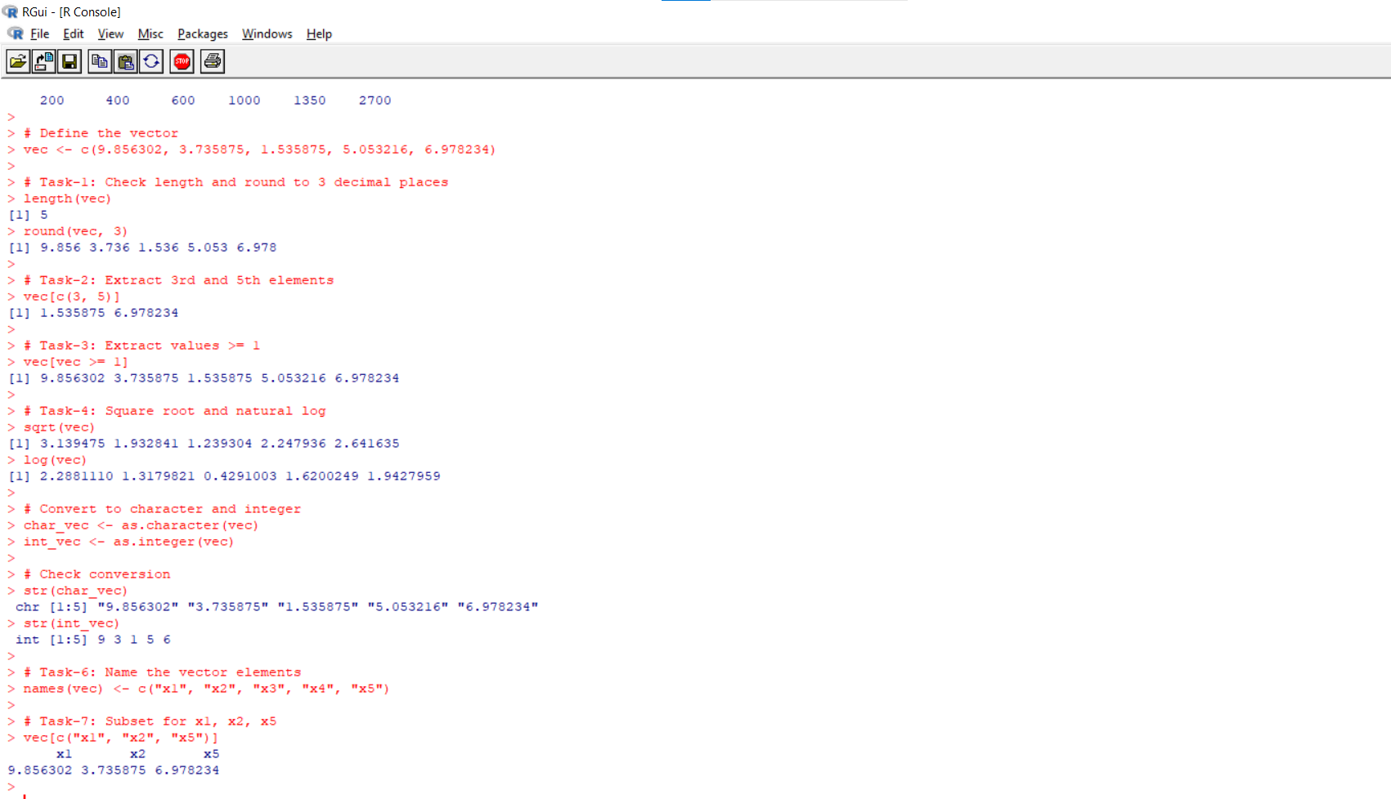

. Generate one vector of size n1=8 of 3’s and second vector of size n2=6 of 5’s and perform the following task.
- Task-1: Combine them into a single vector.
- Task-2: Add an element to the vector obtain in previous step, whose value is 2 and store them under the name “value”.
- Task-3: Abstract all the elements which are at the odd places.
Ans:
vec1 <- rep(3, 8)
vec2 <- rep(5, 6)
combined_vec <- c(vec1, vec2)
value <- c(combined_vec, 2)
value[seq(1, length(value), 2)]
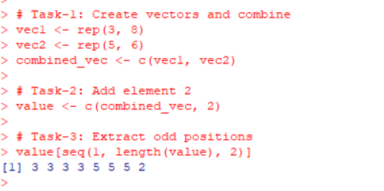

. Define a vector of complex number whose elements are 5+3i, 4-4i, 3-4i, 5+9i, 6+3i, 7+2i and perform the following task.
- Task-1: Abstract the real and imaginary part of the above part.
- Task-2: Calculate the modulus and complex conjugate of the above vector.
- Task-3: Check the type and class of this vector, also use str function to get full detail of this vector.’
Ans:
comp_vec <- c(5+3i, 4-4i, 3-4i, 5+9i, 6+3i, 7+2i)
Task-1: Extract real and imaginary parts
Re(comp_vec)
Im(comp_vec)
Task-2: Modulus and conjugate
Mod(comp_vec)
Conj(comp_vec)
Task-3: Type and class
typeof(comp_vec)
class(comp_vec)
str(comp_vec)
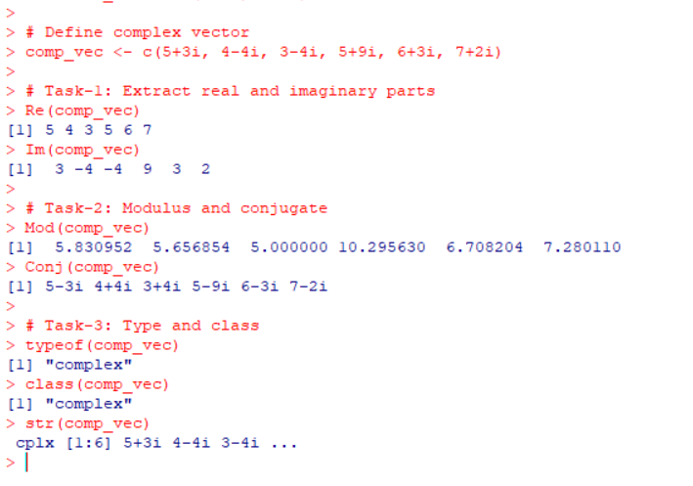

. Generate a vector of 15 elements selecting with 2.5 by a jump of 0.5 and perform the following task.
- Task-1: Check the class and type of this vector.
- Task-2: Convert to this complex vector and save it with name B.
- Task-3: Abstract all the elements which are at the odd places.
- Task-4: Abstract the first Nine elements and then after bind them row wise and column wise. Also store these elements under the name R_mat and C_mat. Perform the testing for vectors or matrix.
Ans:
seq_vec <- seq(2.5, by=0.5, length.out=15)
Task-1: Check class and type
class(seq_vec)
typeof(seq_vec)
Task-2: Convert to complex and name it B
B <- as.complex(seq_vec)
Task-3: Extract odd positions
seq_vec[seq(1, length(seq_vec), 2)]
Task-4: Extract first 9 elements and bind row/column wise
first9 <- seq_vec[1:9]
R_mat <- matrix(first9, nrow=3, byrow=TRUE)
C_mat <- matrix(first9, ncol=3)
is.vector(first9)
is.matrix(R_mat)
is.matrix(C_mat)
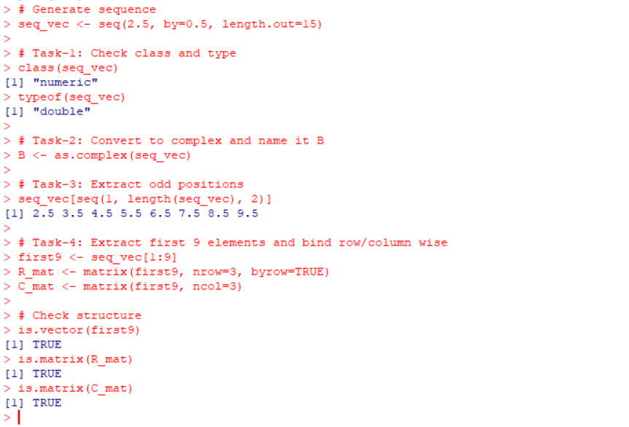
. Define the following matrix with names Matrix_A in R, where
2.10 3.15 −4.09
Matrix_A = [3.22 −3.15 1.12 ]and perform the following tasks.
4.40 −2.30 5.40
- Task-1: Print a number of rows, columns and dimension of the above matrix.
- Task-2: Calculate the transpose, inverse, column sum, row sum, row mean and column mean of the above matrix.
- Task-3: Use R function to print the diagonal elements of the above matrix.
- Task-4: Extract the 3rd column of above matrix.
- Task-5: Extract the 2nd row of the above matrix.
- Task-6: Extract 2nd entry of the 3rd column.
- Task-7: Define the row names as R1, R2, R3.
- Task-8: Define the column names as C1, C2, C3.
Ans:
Matrix_A <- matrix(c(2.10, 3.15, -4.09, 3.22, -3.15, 1.12, 4.40, -2.30, 5.40), nrow=3, byrow=TRUE)
Task-1: Rows, columns, dimension
nrow(Matrix_A)
ncol(Matrix_A)
dim(Matrix_A)
Task-2: Transpose, inverse, sums, means
t(Matrix_A)
solve(Matrix_A) # Inverse
colSums(Matrix_A)
rowSums(Matrix_A)
colMeans(Matrix_A)
rowMeans(Matrix_A)
Task-3: Diagonal elements
diag(Matrix_A)
Task-4: Extract 3rd column
Matrix_A[,3]
Task-5: Extract 2nd row
Matrix_A[2,]
Task-6: Extract 2nd entry of 3rd column
Matrix_A[2,3]
Task-7 & 8: Assign row and column names
rownames(Matrix_A) <- c("R1", "R2", "R3")
colnames(Matrix_A) <- c("C1", "C2", "C3")
Matrix_A
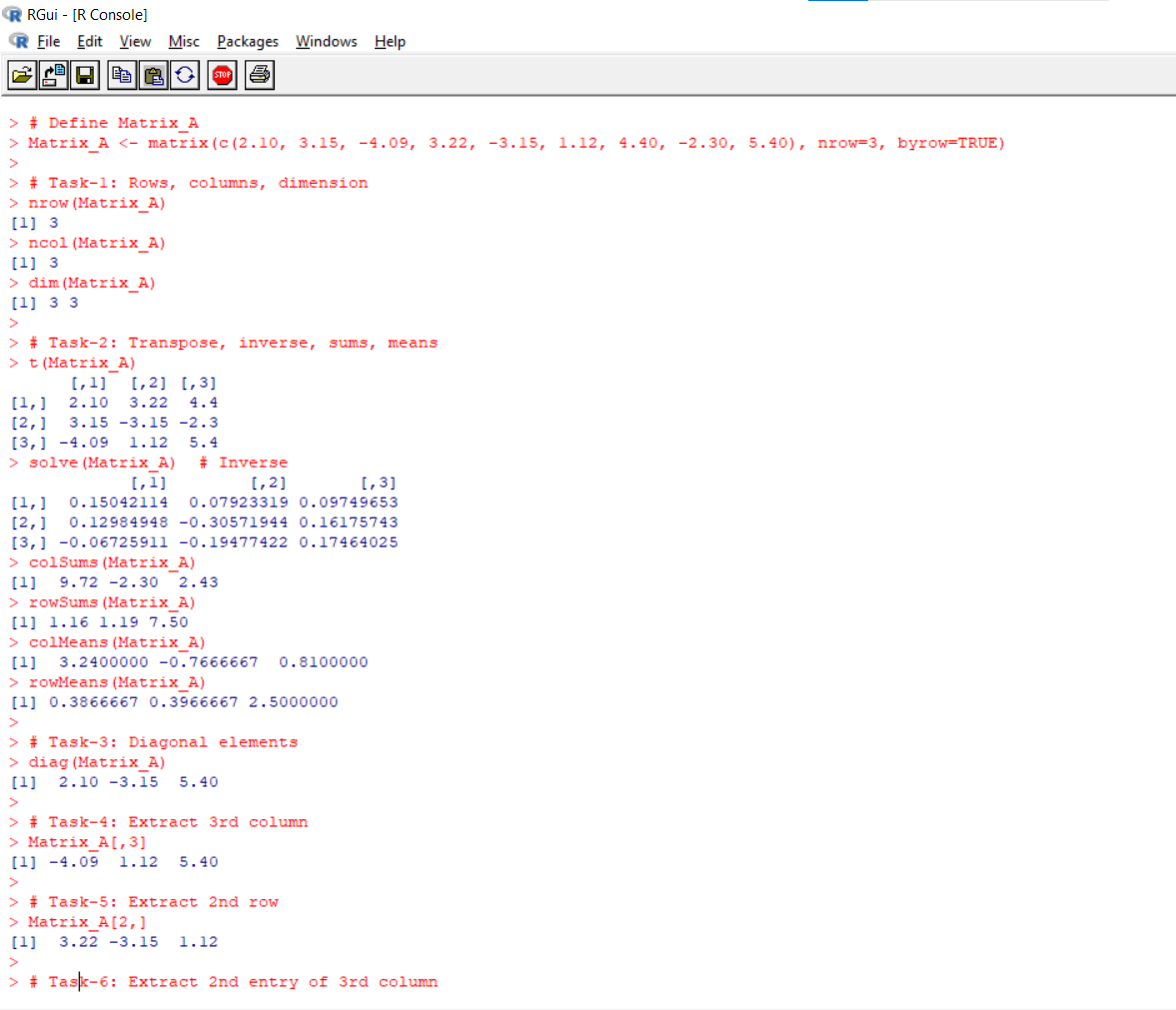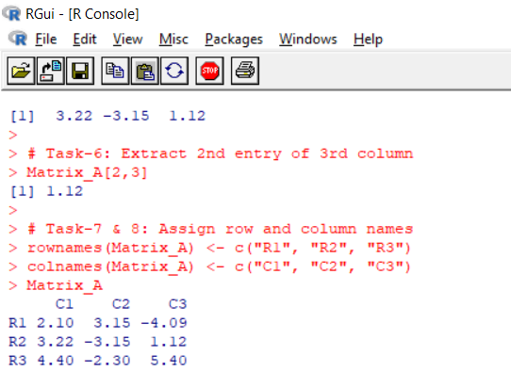
. Generate two sequences each of size 9 starting with 2.5 by a jump 0.25 and 0.50. Using these sequences make two matrices of order 3x3 with the name Sat_P and Sat_R. Also perform the following task.
- Task-1: Perform addition, subtraction and multiplication with the above two matrices.
- Task-2: Extract the 2nd and 3rd column of matrix Sat_P and store under the name Sat_M.
- Task-3: Combine the 3rd column of Sat_R to Sat_M.
- Task-4: Combine Sat_P and Sat_R row wise and column wise.
Ans:
seq1 <- seq(2.5, by=0.25, length.out=9)
seq2 <- seq(2.5, by=0.5, length.out=9)
Sat_P <- matrix(seq1, nrow=3)
Sat_R <- matrix(seq2, nrow=3)
Task-1: Addition, subtraction, multiplication
Sat_P + Sat_R
Sat_P - Sat_R
Sat_P * Sat_R

Task-2: Extract 2nd and 3rd columns of Sat_P
Sat_M <- Sat_P[,2:3]
Task-3: Combine 3rd column of Sat_R with Sat_M
Sat_M <- cbind(Sat_M, Sat_R[,3])
Task-4: Combine Sat_P and Sat_R row and column wise
rbind(Sat_P, Sat_R)
cbind(Sat_P, Sat_R)
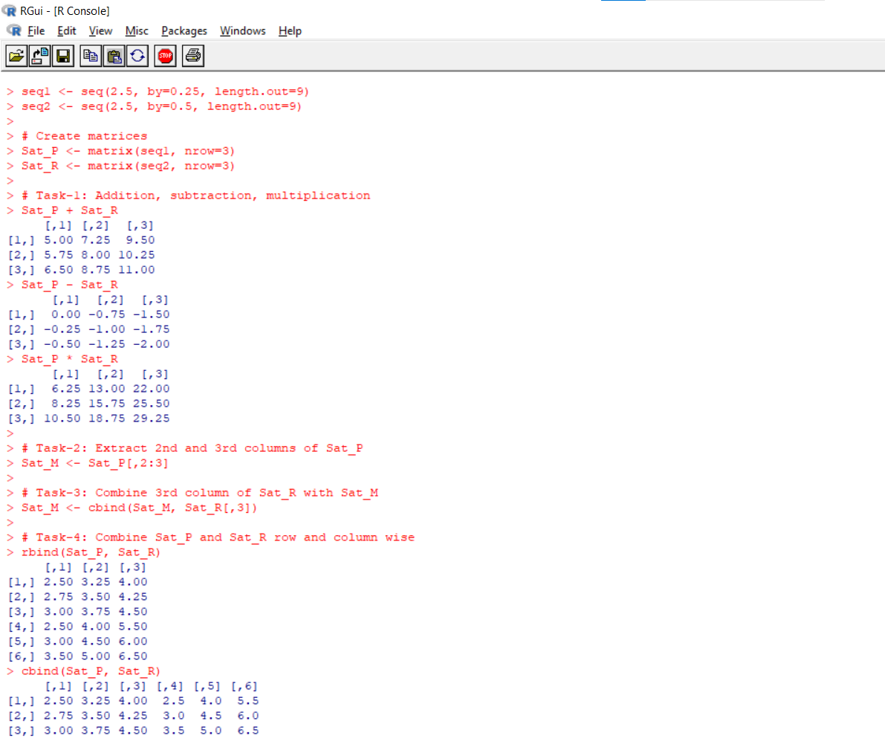
. Consider the following data set-

Tree | S.No. | Age | Circumferences
1 | 1 | 110 | 25
 | 2 | 450 | 48
 | 3 | 660 | 75
 | 4 | 950 | 95
 | 5 | 1100 | 120
2 | 6 | 110 | 40
 | 7 | 450 | 65
 | 8 | 660 | 85
 | 9 | 950 | 105
 | 10 | 1100 | 135
3 | 11 | 110 | 30
 | 12 | 450 | 55
 | 13 | 660 | 70
 | 14 | 950 | 85
 | 15 | 1100 | 115
4 | 16 | 110 | 35
 | 17 | 450 | 45
 | 18 | 660 | 60
 | 19 | 950 | 95
 | 20 | 1100 | 110
5 | 21 | 110 | 38
 | 22 | 450 | 50
 | 23 | 660 | 80
 | 24 | 950 | 95
 | 25 | 1100 | 125
6 | 26 | 110 | 29
 | 27 | 450 | 47
 | 28 | 660 | 72
 | 29 | 950 | 98
 | 30 | 1100 | 118

Create a list name Mydata_Tree by using the above dataset. [Here, the list will have three elements viz, Tree numbers i.e, an order factor indication the three on which the measurement is made. The ordering is according to increase maximum diameters. Tree Age i.e, a numeric vector giving the age of tree (days since 1998/12/31) and Tree Circumferences i.e, a numeric vector of trunk circumferences. This is probably a standard measure known as “circumferences at breast height” in forest.]. Perform the following tasks.
- Task-1: Extract the tree age and tree circumferences from the list obtain above.
- Task-2: Calculate the tree wise minimum, maximum, mean and standard deviation of circumferences.
- Task-3: Can we say the average circumferences of tree 1 is more than average circumferences of tree 4.
- Task-4: Can we say the average circumferences of tree 2 is more than average circumferences of tree 5.
- Task-5: Can we say the average circumferences of tree 3 is more than average circumferences of tree 6.
Ans:
Tree_Age <- c(110, 450, 660, 950, 1100, 110, 450, 660, 950, 1100, 110, 450, 660, 950, 1100, 110, 450, 660, 950, 1100, 110, 450, 660, 950, 1100, 110, 450, 660, 950, 1100)
Circumferences <- c(25, 48, 75, 95, 120, 40, 65, 85, 105, 135, 30, 55, 70, 85, 115, 35, 45, 60, 95, 110, 38, 50, 80, 95, 125, 29, 47, 72, 98, 118)
Mydata_Tree <- list(Tree_Age, Circumferences)
Task-1: Extract tree age & circumference
Mydata_Tree[[1]]
Mydata_Tree[[2]]
Task-2: Min, max, mean, sd
summary(Circumferences)
